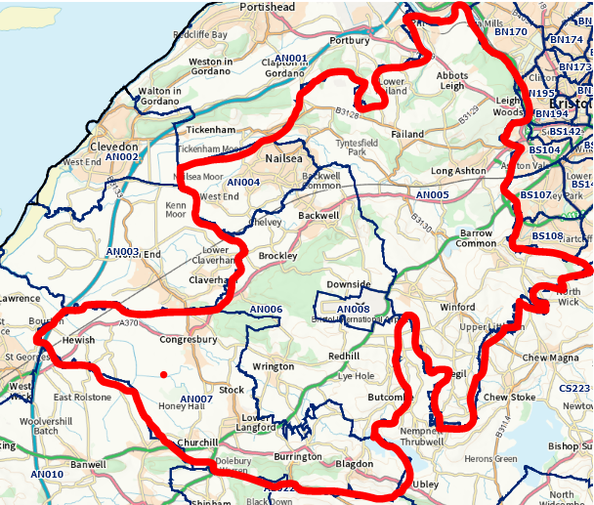
Your Policing Team

Police Officers:
PS 2781 Lee KERSLAKE

A/PS 3467 Paul LEWIS
PC 1954 Bridget GRIFFITHS
PC 4469 Justina LEWIS
PC 4175 Gary MARRIOTT

Police Community Support Officers:

PCSO 6398 Amy HOLLAND
PCSO 8999 Dan JACKSON
PCSO 9382 Connor AITKEN
PCSO 9179 Julie BERCHALL
PCSO 7948 Kate TURNER
PCSO 8471 Sue HAWKINS
PCSO 7280 Chea SCANDRETT
PCSO 7268 Andy GATENBY

Volunteer – Jon Hunter

YOUR NEIGHBOURHOOD TEAM
February 2022

NEWS IN YOUR AREA
Introductions

I wanted to take this opportunity to introduce myself. I’m PS Lee Kerslake, having taken over from Mark Raby late last year. Mark’s absence from Nailsea leaves a huge hole that I will endeavour to do my best to fill and, having seen the immense dedication he had to the area whilst watching from another Neighbourhood Team, I hope to do my best to tackle all the things that affect your quality of life in North Somerset.

Just getting to grips with my team’s area is a daunting prospect. The team is listed to the right and our area is highlighted in red above, one of if not the largest area in the Constabulary stretching from Blagdon to Pill, Nailsea, Long Ashton and Dundry to Congresbury. This sort of area needs great communication, between the team but also between you and us. I am a big fan of being as transparent as I can about local issues and being available as much as possible to discuss and act on issues in the community. You’ll see this in future updates
Get in touch

In an emergency always call 999

For non-emergency matters call us on 101 or report online via www.avonandsomerset.police.uk/
report

To report a crime anonymously, contact Crimestoppers on
0800 555 111 or visit
www.crimestoppers-uk.org

Right now we have a fantastic team who are dedicated to solving community safety issues, we will in months to come tell you about some of our fantastic work, events you can get involved with and we will be asking for you to contact us with anything you feel the police should know. We are your local policing team and I am absolutely passionate about making a difference in the area we all feel so strongly about. So if you need to discuss anything, just get in touch.

PS2781 Lee Kerslake,
Nailsea Neighbourhood Sergeant
Road Safety
Your Investment in Policing

The challenges of policing North Somerset ‘Nailsea area’ is greater than it ever has been. At one stage police officer numbers included a 24/7 response team based at Nailsea Police Station consisting of 5 sergeants and 35 constables, in addition to detectives and a Neighbourhood Team of 6 PCs and 8 PCSOs.

Various reforms have moved officers and removed Nailsea police station leading to an allocation to the area of a neighbourhood team consisting of myself, 4 PCs and 8 PCSOs, with patrol officers based at Weston available for emergency calls though competing with their new geography which includes Burnham, Highbridge and Cheddar.

We continue to work tirelessly to deal with issues in North Somerset and we will continue to focus on those wishing to cause harm within North Somerset. At a time when council tax precepts have included increases to the maximum permitted for policing it is vital you feel you are getting value for money and we are focusing on the things that matter most to you.

If you have any questions about policing in North Somerset please don’t hesitate to contact me and I will endeavour to answer you. Alternatively your PCC is there to ensure you get the best value from policing in your area.

Already I am trying to get to grips with the things that local residents really care about and I can see that road safety is a regular highlight in the conversations I am holding. We are working with Jon Hunter, who is coordinating Community Speedwatch in North Somerset, to strengthen the links between our team and local Watches and I am speaking with the Special Constabulary to increase the resource we have to focus on enforcing against speeding and careless motorists who are the potential sources of danger on our roads. I will update on the progress of this.

What can I do?

When I say I, I mean you… well, if you have video footage of road related offences taking place, whether that be dashcam, phone, bike helmet cam, you can upload it via our website and we will look at the footage and where applicable prosecute offenders. There’s certain criteria which they go through as part of the form (you need clear registration plate and a certain time either side of the offence) but it is really simple and we are prosecuting large numbers of people thanks to this public input. The link is simple too:

www.avonandsomerset.police.uk/roads

Bike Register

We have been unfortunately suffering a large number of bike thefts in the area – we are working hard to identify, prosecute and take off the streets those responsible but alongside this we also have opportunities to register your bike on Bike Register. Usually tagging and registering a bike costs £12.99 via the website, but we offer this for free. We hold events, but also if you are interested as a group, street or area just let us know and I will get our team to come out to you… it’s really simple and we do all the work for you!

